**LAPTOP REQUEST CATALOG ITEM**

**Problem Statement**:

Employees in the organization need a quick and efficient way to request laptops for work. The current process is manual and prone to delays, with no dynamic form behavior to guide users or ensure accurate data collection. To address this, a Service Catalog item needs to be created, allowing users to easily request a laptop, with dynamic fields, clear instructions, and additional functionality like resetting the form if needed. The solution should also ensure all changes are tracked for governance and deployment.

**Output**:

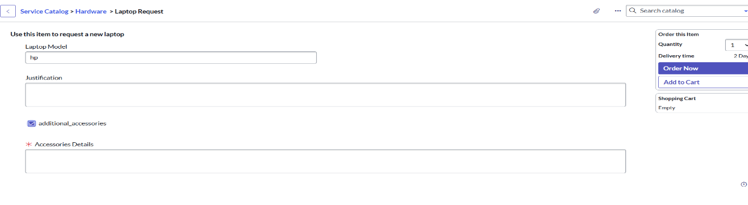

**Project Overview**

The Laptop Request catalog item in ServiceNow is designed to streamline the process of  requesting laptops for employees within an organization. Instead of relying on manual  communication or emails, users can submit a structured request directly through the Service  Catalog.

The catalog item provides employees with a simple and userfriendly interface where they can  specify their laptop requirements such as model type, operating system, accessories, or  additional software. Once submitted, the request is automatically routed through predefined  workflows, including approvals and task assignments for the IT fulfillment team.

The purpose of this catalog item is to:

● Improve efficiency by reducing manual effort in handling laptop requests.

●Enhance user experience with a guided and transparent request submission

process.

●Ensure compliance with organizational policies by enforcing approval flows.    ●Provide tracking and visibility to both requesters and approvers throughout the request  lifecycle.

Ultimately, this project supports automation and standardization of IT asset requests, ensuring  that employees receive the right devices quickly while IT maintains control and governance .

**Business Requirement / Objective**

Modern organizations rely heavily on laptops as essential tools for daily operations.  Traditionally, employees requested laptops through emails, phone calls, or inperson  communication with the IT team, which often led to delays, lack of tracking, and inconsistent  approvals. This manual process also made it difficult for IT to manage inventory, ensure  compliance, and maintain service quality.

The Laptop Request catalog item in ServiceNow addresses these challenges by providing a  centralized, automated, and standardized process for requesting laptops.

**Objectives of the project**:

●Streamline request handling by enabling employees to raise laptop requests directly  through the Service Catalog.

●Standardize information collection using predefined variables (such as laptop type,  configuration, and accessories).

●Automate approval workflows so that requests are reviewed and authorized by  managers before fulfillment.

●Enhance visibility and transparency by allowing both requesters and approvers to track  the status of requests in real time.

●Improve IT efficiency by generating fulfillment tasks automatically for the IT team.

●Ensure compliance with organizational policies regarding asset allocation and cost  management.

This project ensures that the organization delivers laptops to employees in a timely, consistent,  and controlled manner while reducing manual effort and improving user satisfaction.

**Scope**

The scope of this project defines what is covered under the Laptop Request catalog item and  what falls outside its boundaries.

**In-Scope**

●Creation of a Service Catalog Item for Laptop Requests in ServiceNow.

●Configuration of variables to capture requester details and laptop requirements (e.g.,  laptop model, operating system, accessories, justification).

●Use of Flow Designer / Workflow to automate the approval and fulfillment process.

● Implementation of manager approval before request fulfillment.

●Automatic generation of fulfillment tasks for the IT support team to process the request.

●Notifications for requester, approver, and fulfillment team (e.g., submission confirmation,  approval/rejection, completion).

●Access control to ensure only eligible users can submit requests.

●Request tracking via ServiceNow portal for end users.

**Out-of-Scope**

●Procurement of new laptops from external vendors (only internal stock is considered).

●Integration with thirdparty asset management or procurement systems.

●Automation of hardware delivery logistics outside the ServiceNow platform.  ● Management of non-laptop assets (desktops, mobile devices, peripherals).

●Handling of software license requests (separate catalog items handle software)

**Design / Implementation Details**

1.Update set

Create Local Update set

* Open service now.
* Click on All >> search for update sets
* Select local update sets under system update sets
* Click on new
* Fill the following details to create a update set as: “Laptop Request”
* Click on submit and make current
* By clicking on the button it activates the update set .

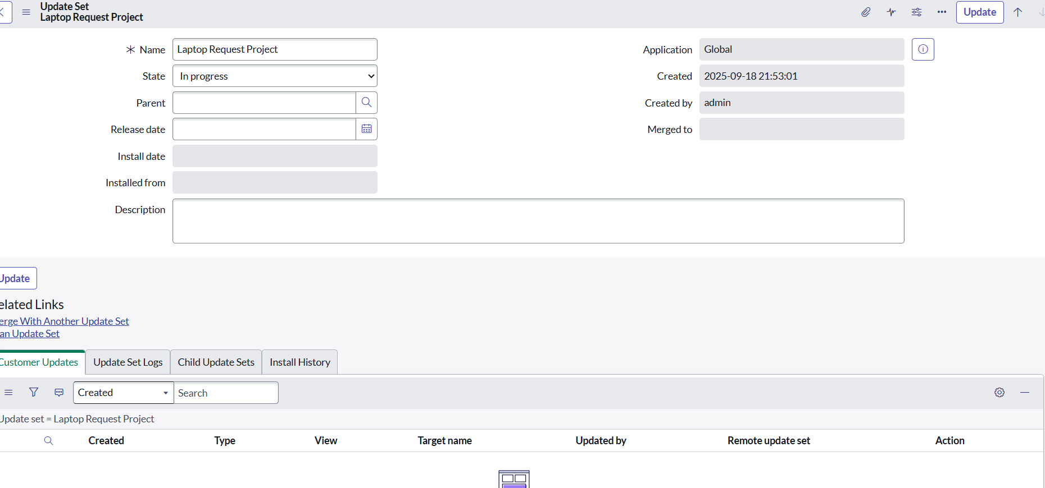

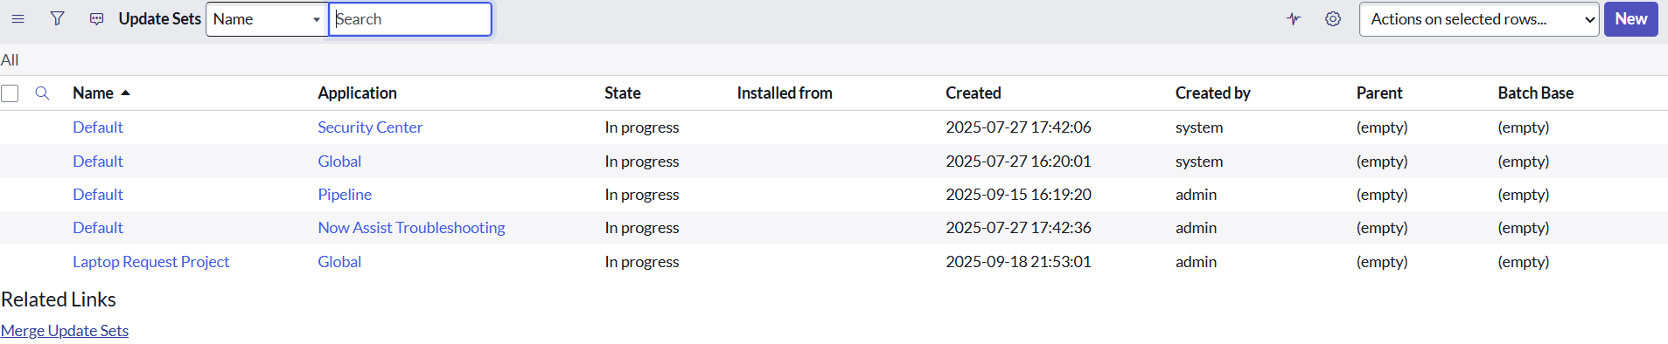

2.Service Catalog Item

2.1: Create Service Catalog Item

* Open service now.
* Click on All >> service catalog
* Select maintain items under catalog definitions
* Click on New.
* Fill the following details to create a new catalog item

Name: Laptop Request

Catalog: service Catalog

Category: Hardware

Short Description: Use this item to request a new laptop

* Click on ‘SAVE’

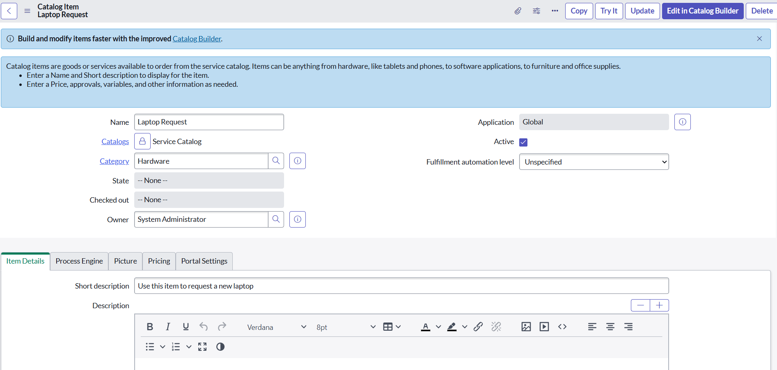

2.2: Add variables

Step1:

* After saving the catalog item form scroll down and click on variable(related list)
* Click on new and enter the details as below

Variable 1:Laptop Model

Type: Single line text

Name: laptop_model

Order:100

* Click on submit
* Again click on new and add Remaining variables in the above process

Variable 2:Justification

Type: Multi line text

Name: justification

Order:200

Variable 3:Additional Accessories

Type: Checkbox

Name: additional_accessories

Order:300

Variable 4: Accessories Details

Type: Multi line text

Name:accessories_details

Order:400

Step2:

* After adding above variable which are added to newly created catalog item
* Then save the catalog item form

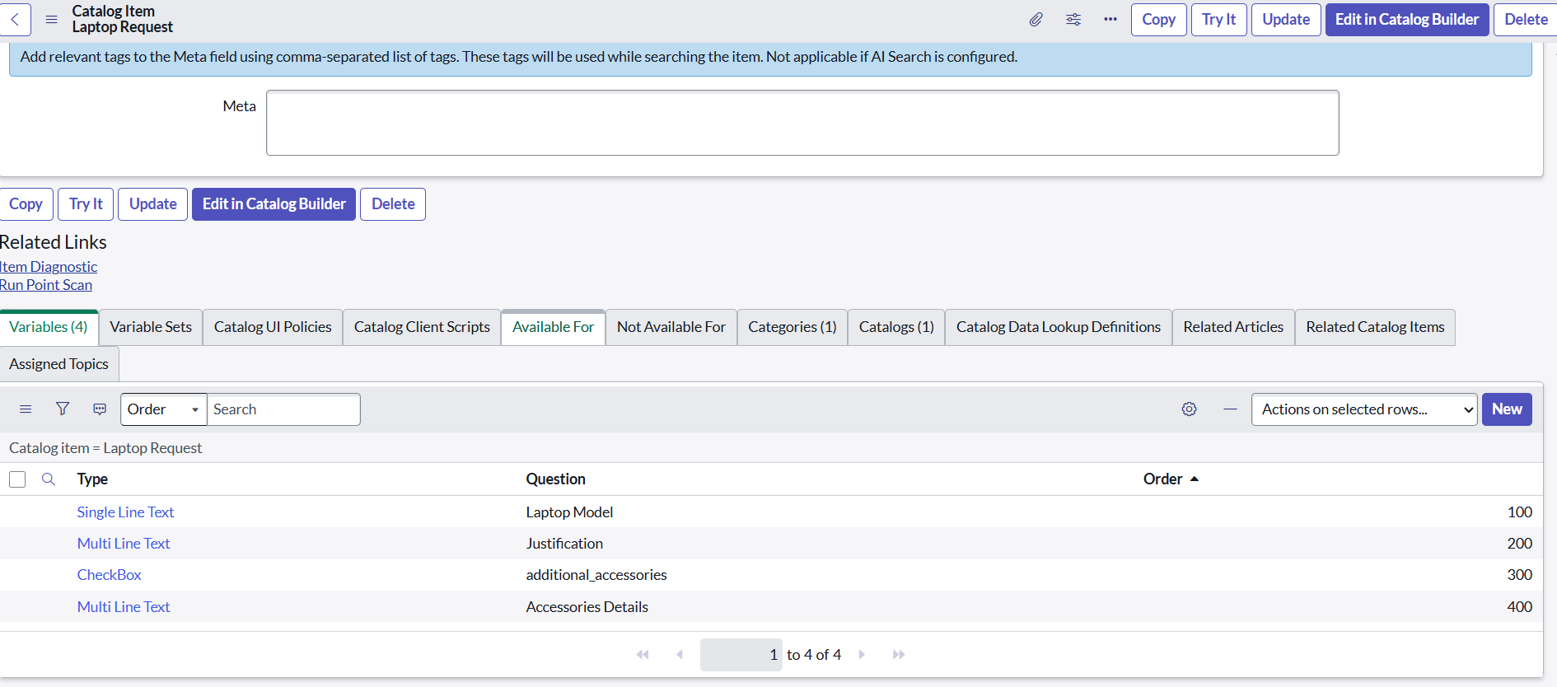

3.UI Policy

Create Catalog Ui policies

* Click on all>> search for service catalog
* Select maintain item under catalog definition
* Search for ‘laptop request’ which is created before
* Select ‘laptop request’ and scroll down click on “Catalog Ui policies”
* In the catalog ui policies related list tab click on new
* Give short description as: show accessories details
* Set the Catalog Condition in the related list tab ‘when to apply’
  + - [field: additional_ accessories, operator: is, value: true
* Click on save.(do not click on submit)

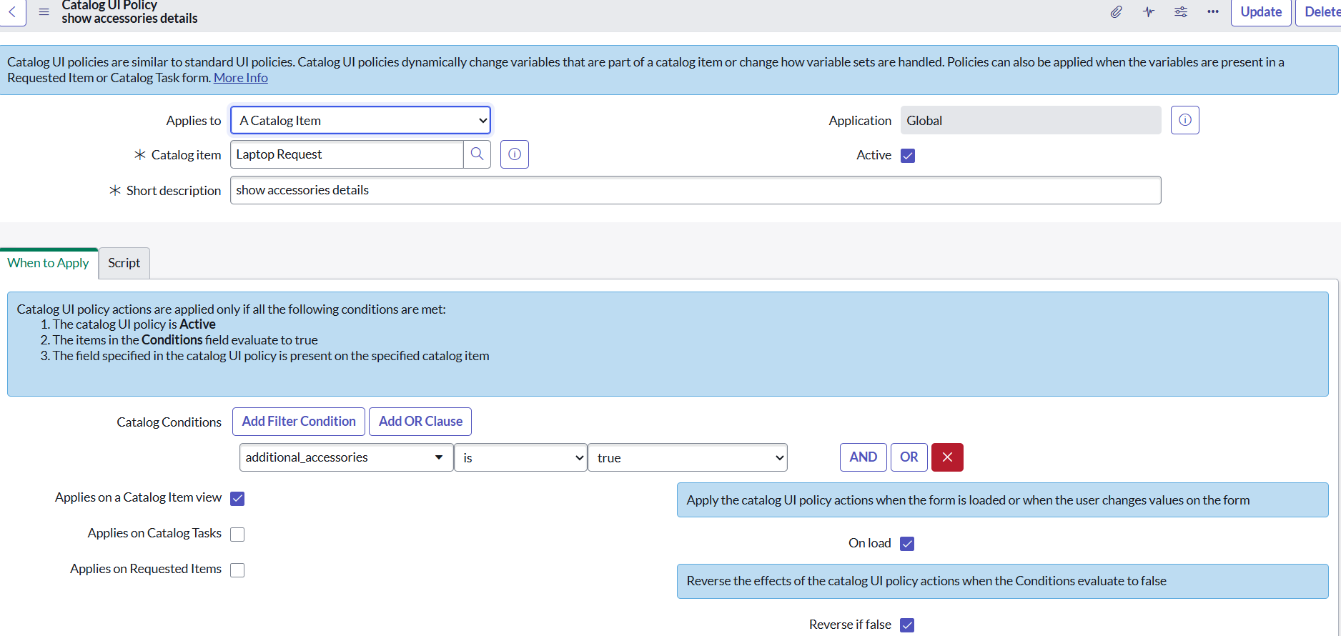

* Scroll down and select ‘catalog ui action’
* Then click on new button
* Select variable name as: accessories_details Order:100 Mandatory: True Visible : True
* Click on save and again click save button of the catalog ui policy form

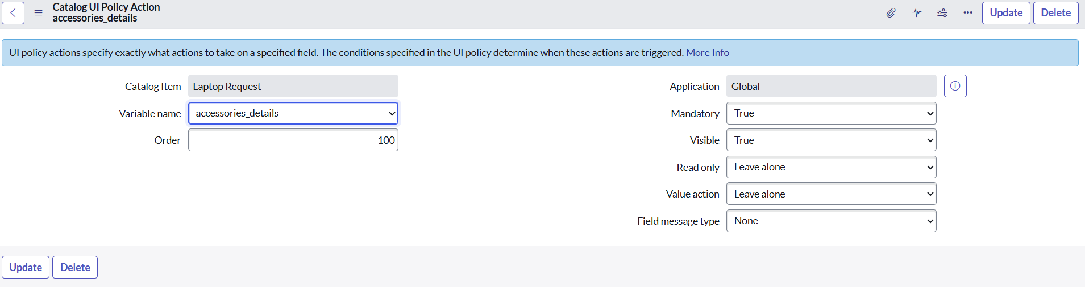

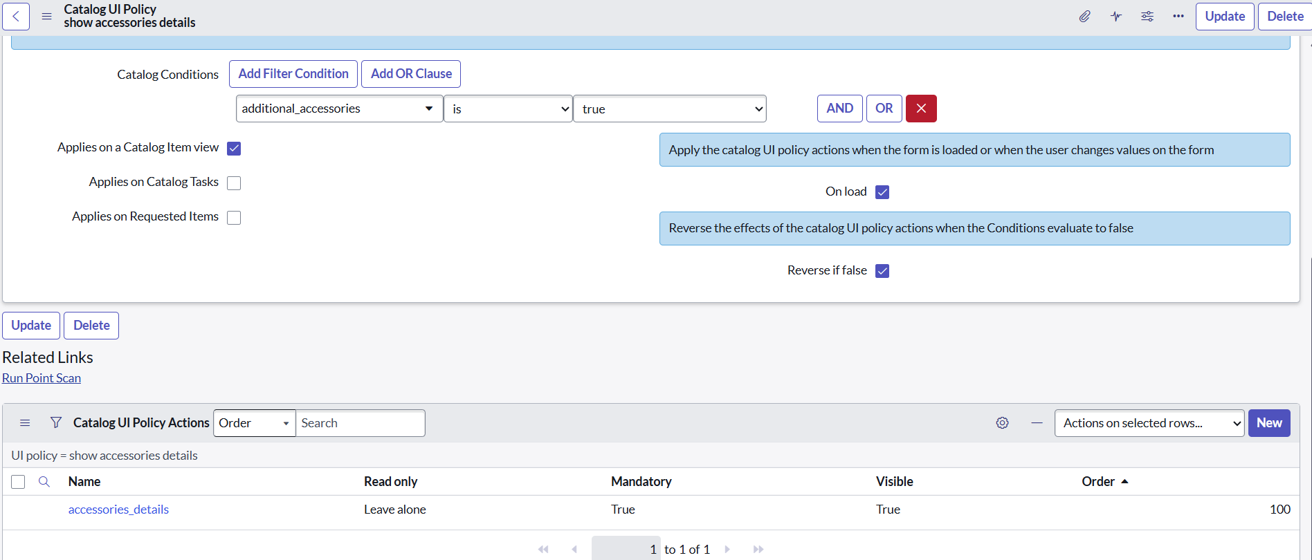

4.UI Action

Create ui action

* Open service now.
* Click on All >> search for ui action
* Select ui actions under system definition
* Click on new
* Fill the following details to create ui action
  + Table: shopping cart(sc_cart)
  + Order:100
  + Action name: Reset form
  + Client : checked
  + Script:

function resetForm() {

g_form.clearForm(); // Clears all fields in the form

alert("The form has been reset.");

}

* Click on save

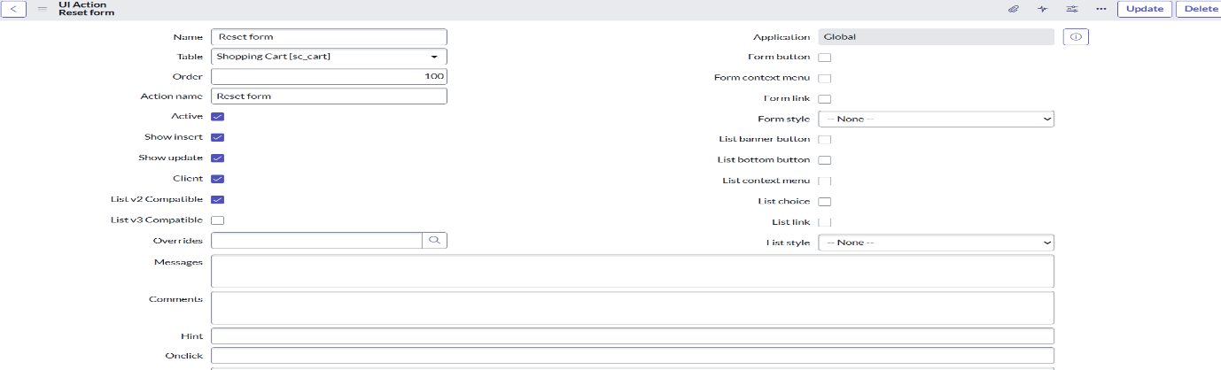

5.Export Update set

Exporting changes to another instances

* Click on All >> search for update sets
* Select local update set
* Select created update set i.e. ‘Laptop Request Project’
* Set the state to ‘Complete’
* In the related list Update tab, updates are visible which we perform under this update set.
* Click on export to XML ,it download one file

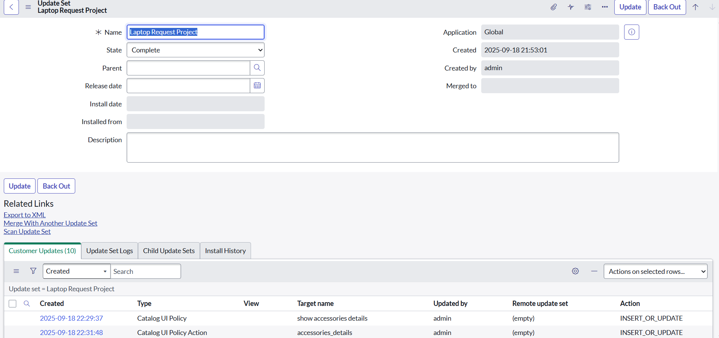

6.Login to another Instance

Retrieving the update set

* Open another instance in incognito window
* Login with credentials
* Click on all>> search for update sets
* Select “Retrieved update set” under system update set
* It open retrieved update set list and scroll down
* Click on Import update set from XML

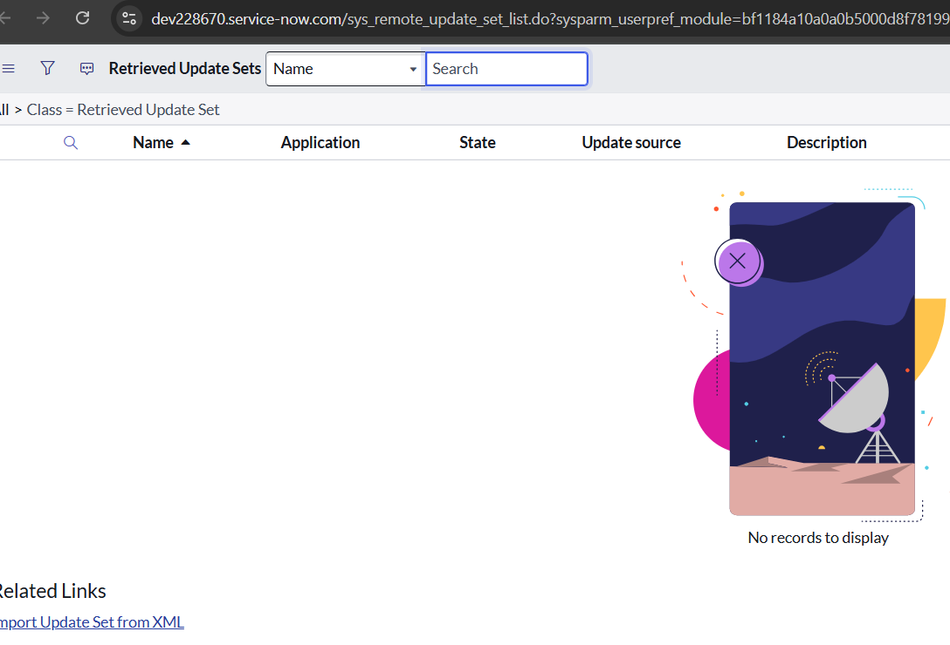

* Upload the downloaded file in XML file
* Click on Upload and it gets uploaded.

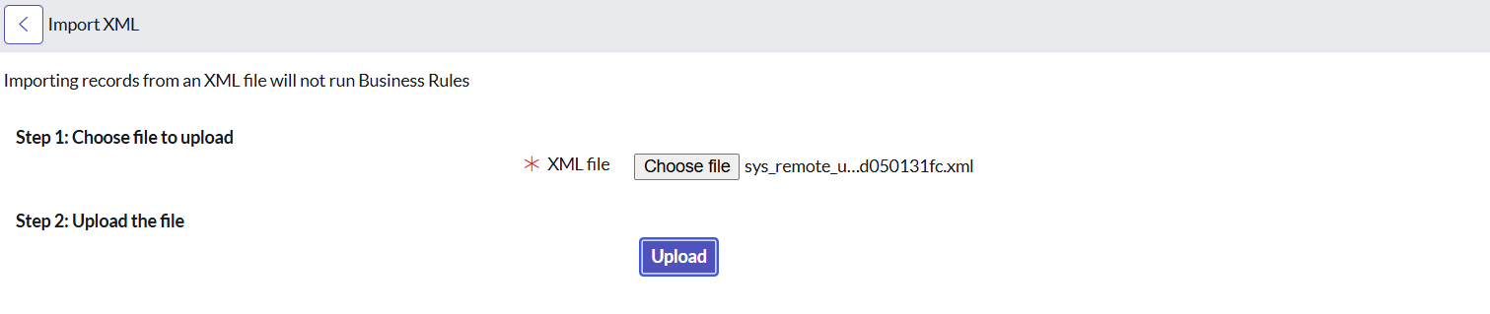

* Open retrieved update set ‘laptop request project’
* Click on preview update set

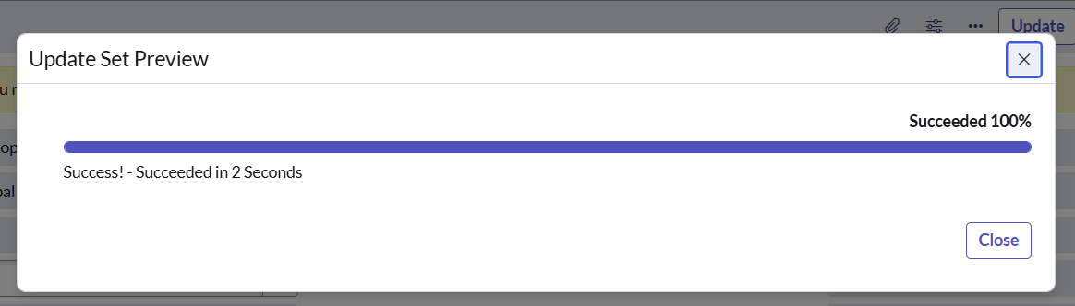

* And click on commit update set
* And also see the related tab updates

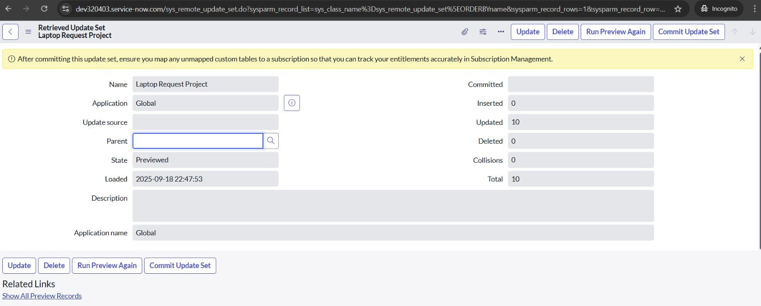

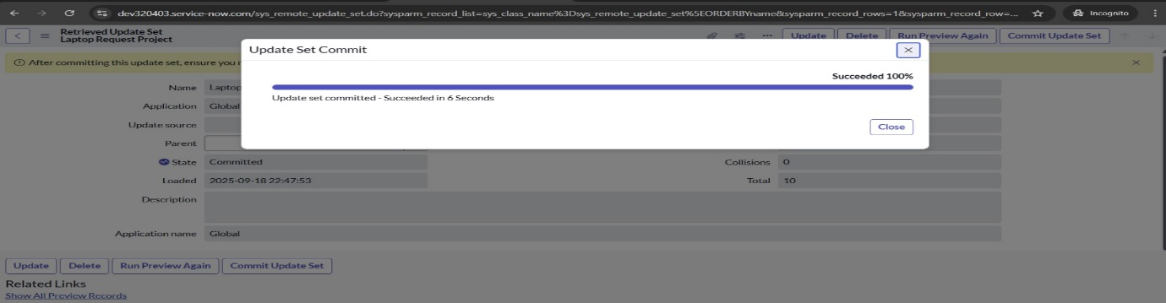

* After commiting update set in this instance we get all updates which are done in the previous instance

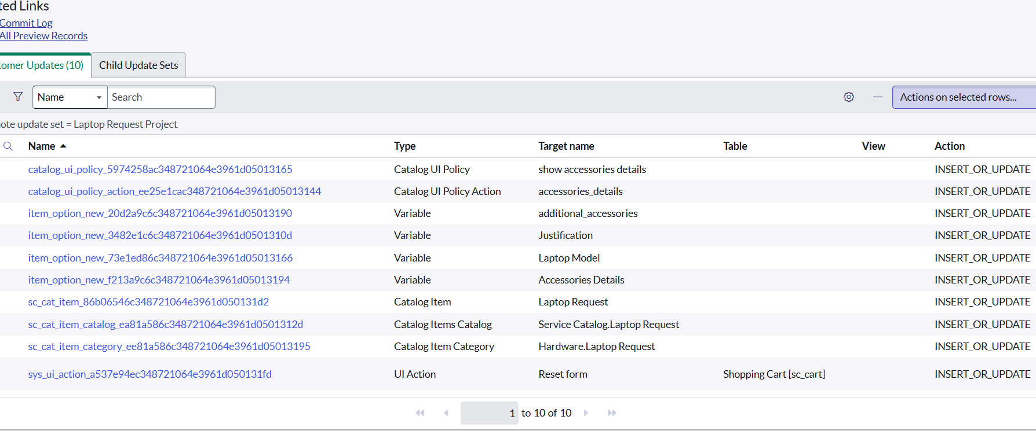

7.Testing

Test Catalog Item

* Search for service catalog in application navigator in target instance
* Select catalog under service catalog
* Select hardware category and search for ‘laptop request’ item

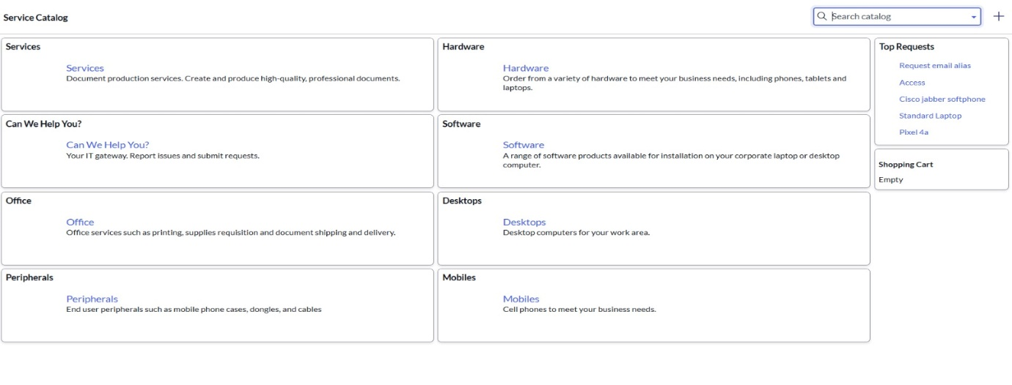

* Select laptop request item and open it

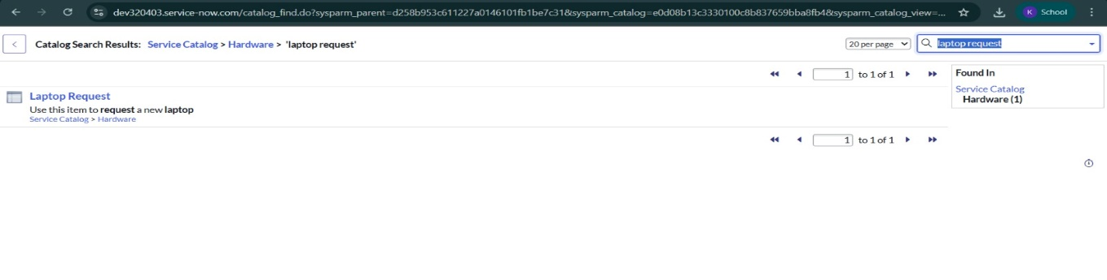

* It shows three variables only

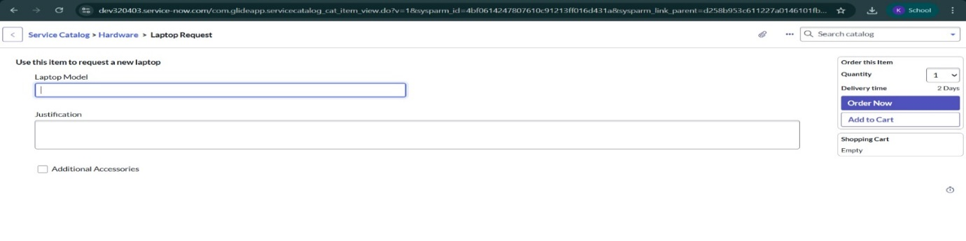

As per our scenario, when we click on additional accessories checkbox then accessories details fields is visible and that should be mandatory.Now see the results,it fulfills our requirements.

**Result**



**Conclusion**

The Laptop Request Catalog Item project successfully streamlines the process of requesting  laptops within the organization by leveraging ServiceNow’s Service Catalog capabilities. By  creating a dynamic and automated catalog item, the project provides employees with an  intuitive, userfriendly interface that minimizes errors, reduces manual effort, and improves  overall efficiency.

The implementation of variables, UI policies, UI actions, and automated workflows ensures that  requests are captured accurately, routed for necessary approvals, and fulfilled in a timely  manner. Additionally, the migration of configurations through update sets demonstrates how  ServiceNow supports smooth transitions between development, test, and production  environments.

This project clearly highlights how ServiceNow can replace manual, error-prone processes with  standardized, automated, and usercentric solutions. It not only improves service delivery and IT  governance but also enhances employee satisfaction by offering a modern and transparent  request experience.

